**Chapter 7: Maths goes into space**

1. **Introduction**

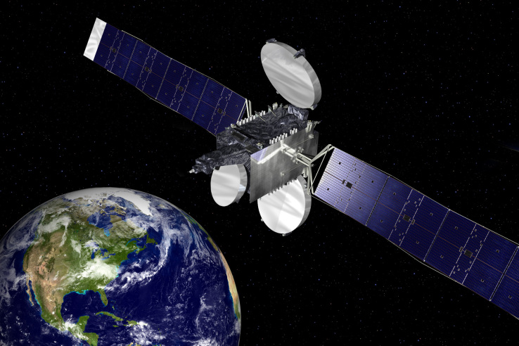

***Figure 1.*** *A satellite orbiting the Earth. Without mathematical models used to predict its orbit, it would never have got into space.*

As we saw in Chapter One, one of the earliest, and perhaps one of the most important, of the applications of the ideas of mathematical modelling, came from studying the Solar system. Mathematical modelling continues to be a powerful tool in opening up the possibilities of outer space and in showing us the possibilities for the future. It is thus fitting to end this book by looking at the applications of mathematics to studying space.

Outer space has fascinated human beings ever since we developed enough intelligence to ask questions about the world that we lived in. Long thought to be the realm of the Gods, space was considered to be beyond our comprehension, and studying it was even blasphemous. However, brave pioneers looked up and started to study carefully what they saw. The resulting understanding of the nature of space has had profound impacts on human civilisation. As agriculture developed and crops had to be sown at the right time of the year, so it became profoundly important to understand the seasons and the motion of the sun. Knowing the motion of the sun also led to an understanding, and measurement, of time. Later it was realised that there were other heavenly bodies such as the stars, moon and planets and their motion was studied and analysed in terms of mathematics. Understanding these was very important in the development of navigation (from the earliest se farers onwards) and (perhaps less usefully) in the growth of astrology. Research into space has both been an enormous stimulus to the growth of science and technology in general, and of mathematics in particular. Perhaps the most important example of this is the development of calculus. Space research has also greatly benefited from developments in mathematics. Without mathematics we would never have had the moon landings for example, or to have been able to launch any satellite. But the application of mathematical models linked to space was also the foundation of our ability to predict the seasons, eclipses, to navigate on the oceans, and to communicate reliably over vast distances, It is certain that mathematical models will play a dominant role in the future of all and any technology that goes into space.

Space is now a very big business with a total value of commercial investment on space technology estimated at $50 Billion! This fact was recently recognised by the UK Government who identified Space Technology as the second of their eight great technologies**.** To give some idea of the scale, in 2016 there were 85 rocket launches into space (of which 79 were successful), there were 87 in 2015 and 92 in 2014. Most of these launched satellites into near Earth orbit. it is currently estimated that there are 4 256 such satellites in orbit of which 1 419 are still active (although there may be secret satellites that we don’t know much about. See the Editorial in [1] for more details of the scale of this activity. We then can add to this the rarer, but very glamorous, activity of sending satellites (and even people) to other bodies such as the moon, Mars, comets, the distant planets and beyond. I grew up in the 1960’s and can testify to the huge impact that the moon landings had on my generation, including awakening and stimulating my own interest in science and maths!

However it is the day to day work of satellites which is making a huge difference to the modern world. This includes the transmission of huge amounts of data, GPS navigation, remote sensing, weather observations, relaying mobile phone messages, agricultural monitoring, whale spotting (yes it can be done) as well as giving us a window to space from space. It is hard to imagine how we would function without all of this technology in space, most of which would not work at all if it was not for the application of a wide variety of mathematical ideas.

In this chapter we will start by looking at the early days of space technology, before we sent anything into space itself. We will then look at the technology behind orbital satellites. We will then look at how satellites (and also Apollo) were guided beyond the orbit of the Earth to the moon and the planets. Next we will take a look at deep space showing how Einstein’s General Relativity not only describes the structure of the universe, but is also important in the functioning of GPS satellites. Finally we will come back closer to Earth with a bit of space Origami.

1. **Space from Earth**

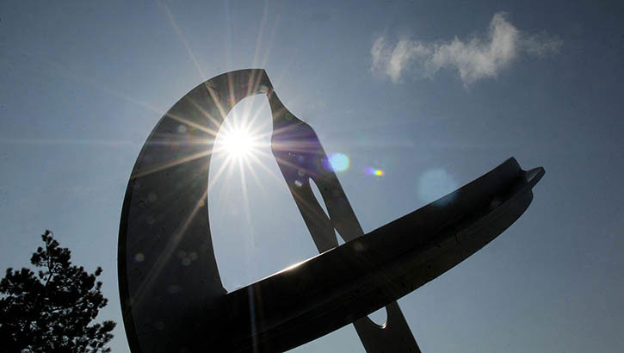

***Figure 2.*** *The sundial at Simon Fraser University, Canada. The pointer (gnomon) has a special shape which corrects for the equation of time, which is the variation in the length of the day throughout the year.*

As I said in the introduction, space has been studied since the earliest times, but it was the Chinese and the Babylonians that made the first serious studies of it by using mathematical models. A reason for this was simple; it was clear that the heavens governed the seasons, and it was the understanding of the seasons that was vital for agriculture. Indeed in the book of Genesis we read

*And God said, Let there be lights in the firmament of the heaven to divide the day from the night; and let them be for signs, and for seasons, and for days, and years.*

We now know that the changing seasons are due to the tilt of the Earth’s axis, and the change in the angle that the Sun makes to the horizon during the year. Whilst this was not known to the ancients, it was clear to them that the Sun governed their lives. In order to work out when was the best time to plant crops they had to predict when the Sun would be in the right part of the sky, and to do this they needed an accurate *calendar*. Creating this was an early application of the mathematics of space to human life. To produce a calendar it was important to know the length of the year. This is not as simple as it looks as the year is 365.2422 days long, which is not an easy number to calculate. The Babylonian calendar used the value of 365 days, which quickly lead to a loss of accuracy. The Egyptian and later Julian calendars used instead the value of 365.25 days. To achieve this the leap day was introduced so that there are 365 days in a normal year, and in a leap year (every four years) there are 366 days. Close but not quite close enough. The Gregorian calendar improved on this by omitting leap years that fall on 100 years. Because 97 out of 400 years are leap years, the mean length of the Gregorian calendar year is 365.2425 days, which is much closer to the value of 365.2422 and is the one in main use throughout the world. As a result the seasons can be predicted with great accuracy. Further mathematics was needed in order to account for the motion of the Moon and (amongst other things) to calculate the date of Easter Sunday, which was defined in 325AD by the Council of Nicaea to the first Sunday after the first full Moon occurring on or after the March equinox. It is said that this tricky calculation (it is difficult because the period of the orbit of the moon is a complex fraction of the year) kept mathematics alive during the middle ages. Similar (but harder) calculations are needed to determine the tides, and the need to do these were one of the factors leading to the invention of the analogue computer. Mathematics was also employed by the ancients to calculate the dates of solar eclipses. The Chinese realised that these occurred with a certain regularity and could be predicted by exploiting patterns in number sequences related to the regular periods of the Sun and of the Moon. The *Chinese Remainder Theorem* in number theory. The earliest known statement of the theorem, appeared in the 3rd-century book [*Sunzi Suanjing*](https://en.wikipedia.org/wiki/Sunzi_Suanjing) by the Chinese mathematician Sunzi, and asked the question

*What numbers have remainder 2 when divided by 3, remainder 3 when divided by 5, and remainder 2 when divided by 7?*

I will leave it to you to find the answer. The Chinese remainder theorem led to the mathematical theory of congruences. Much later, in the 1801 in his book *Disquisitiones Arithmeticae* [2] C.F. Gauss, arguably the greatest ever mathematician, used the Chinese remainder theorem on a problem involving calendars, namely, "to find the years that have a certain period number with respect to the solar and lunar cycle and the Roman indiction." All of this shows that pondering the questions of space can no only be helped with mathematics but also leads to great mathematical discoveries.

The observation of space from Earth has had a number of other consequences of direct benefit to humankind. One of these has been in telling the time. It is undeniable (though slightly sad) knowing the time at any point in the day is of huge importance to the running of a civilised society. The time of the day can be determined by looking at the path of the Sun through the sky so that (in the Northern Hemisphere) is rises in the East and sets in the West and is most Southerly, and highest in the sky, at Noon. It was realised early on that the Sun’s movements were very regular, and understanding this led to the invention of the sundial which tells the time by casting a shadow. The classic sundial design is illustrated in Figure 3 (although see Figure 2 for a more advanced design of sundial which takes into account the varying length of the day throughout the year.)

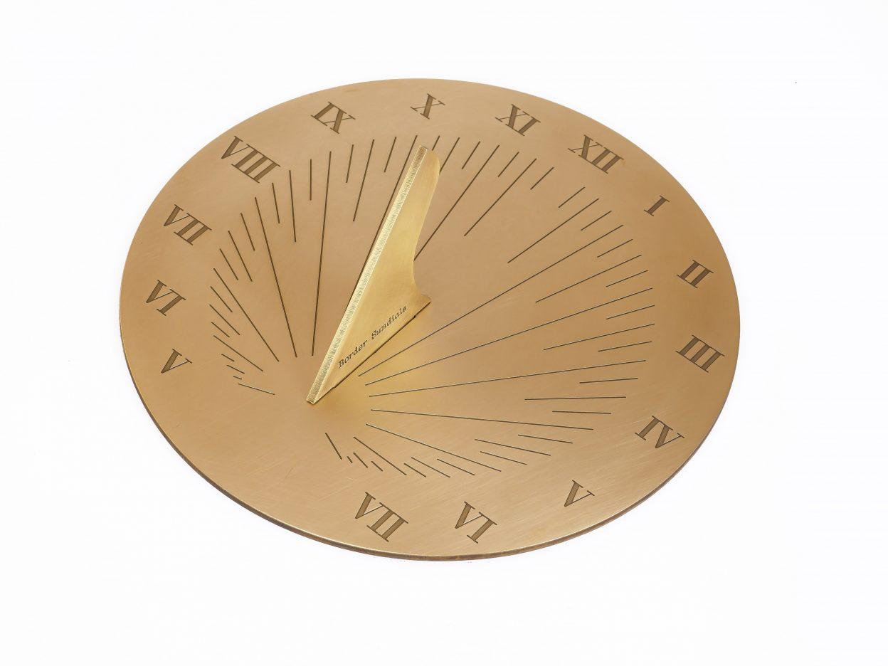

***Figure 3*** *A classical sundial showing the angled gnomon and the lines for each of the hours*

A lot of mathematics has to go into the design of this, including the angle of the pointer (or gnomon) which is the same as the latitude of the user, and also of the angle of the various lines for the times. More advanced sundials, such as the one illustrated at the start of this section (and which can be found at Simon Fraser University in Canada) have a more complicated design of gnomon (in the shape of an Analemma) which accounts for the fact that the length of the day (measured from Noon to Noon) is not exactly 24 hours but varies by up to 15 minutes from the mean value of 24 hours throughout the year. (This is why GMT is Greenwich *Mean* Time). My own favourite design of sundial is the Analematic Sundial [3] which has the shape of an ellipse (see later) and uses a (vertical) human being to cast the shadow, as shown in Figure 4.

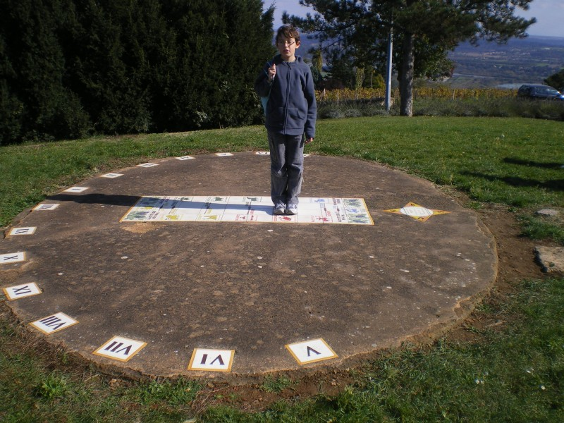

***Figure 4*** *An analemmatic sundial with a human figure as the gnomon. The person needs to stand at a different place for different dates of the year.*

An analemmatic sundial can be found outside the House of Commons in the UK and in many school playgrounds (modesty forbids me to say who designed the latter). Sundials in general were used heavily to tell the time until the invention of the mechanical clock, and used correctly they can be very accurate indeed. We get the concept of *clockwise* from the fact that in the Northern Hemisphere the shadow on a sundial goes clockwise around the dial.

1. **Space close to Earth**
   1. **Placing a satellite in orbit**

Now, in the 21st Century, instead of just looking at space from the Earth, we are also able to look at the Earth from space. The reason that we can do this is, of course, that we can send satellites into space with cameras on them. Such satellites are both send into space, and their location changed in space, through the use of rockets. This idea was (arguably) first proposed as a serious scientific endeavour by Oberth in the 1930s [1] and then developed by many others since, including Werner Von Braun working first in Germany, and then America, and also Sergei Korolev for the USSR. As is well known the first satellite into space was Sputnik, launched in 1957 (and causing a great shock to the USA in the process). Much the same technology is still in use today. The launch of a satellite on a rocket consists of a short period of powered flight during which the satellite is lifted above the Earth's atmosphere and accelerated to orbital velocity by the rocket, assisted by the 0.5km/s rotational velocity of the Earth. Usually such a rocket has multiple stages, with large fuel bearing stages discarded early on during the flight. The powered part of the flight finishes when the rocket's last stage burns out. At this point the satellite begins its free flight subjected (at least initially) only to the gravitational pull of the Earth.

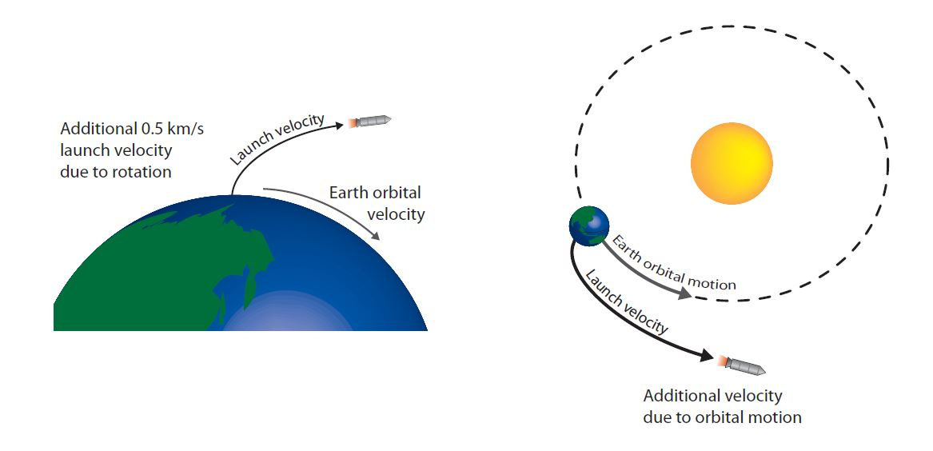

***Figure 5.*** *Launching a rocket into space, with some help from the Earth’s rotation.*

When the rocket is launched it initially takes off vertically, and then bends in the direction of the Earth’s rotation to insert the satellite into a horizontal orbit. Such an orbit is shown above. The essential physics of this process was first identified by Galileo. When a body is in a circular motion of radius r and it has velocity V then it has a constant *centripetal acceleration* a *towards the centre of the circle* which is given by





Now provided that the satellite is close to the Earth it will have an acceleration of towards the centre of the Earth due to the action of the gravitational attraction of the Earth.

Thus a near Earth circular orbit can be achieved provided that a = g so that



The radius of the Earth is R = 6371 km, and provided that the satellite is in a near Earth orbit, we can take r to equal this value. It then follows that V = 7.9 km per second. This is called the *insert velocity* and is a very high speed, which could only be obtained by using the large rockets developed after the Second World War. More generally, the gravitational acceleration g due to the Earth at an orbital radius of r is given by



where G is the Gravitational constant G = 6.67*10-11 m3 kg-1 s-2 , and M = 5.972* 1024 kg is the mass of the Earth. The insert velocity for a circular orbit with a radius of r is then given by



If the insert velocity differs from the value v given above then the satellite will typically take an elliptical orbit rather than a circular one.

**3.2 Geostationary satellites**

The further away a satellite is, the slower it needs to travel to stay in orbit. Now the Earth takes 24 hours or 86400 seconds to rotate. The angular velocity of the rotation of the Earth is then given by ω = 2π/86400 = 7.27 * 10 -5 radians s-1 .

If the satellite travels at the right distance r then its angular velocity will exactly match that of the Earth’s rotation. We find this by solving the equation



This gives r = 42 000 km. A satellite at this radius from the centre of the earth is then in a *geostationary orbit* and will appear stationary if viewed from the surface of the Earth. This is very useful for a satellite used to relay communications around the world, such as the Telstar satellites launched in the early 1960s. The science fiction author Arthur C. Clarke (of 2001 fame) predicted the use of geostationary orbit for communications satellites in the prophetic paper [4] published in Wireless World. In his honour a geostationary orbit is also known as a *Clarke Orbit* and the many satellites in a geostationary position orbit in the *Clarke Belt.* Once in a geosynchronous orbit a satellite can be used to communicate rapidly with the Earth both to relay signals starting from Earth (such as TV programmes or mobile phone messages) from one side of the planet to another (which could not have been achieved before satellites due to the curvature of the Earth), or to transmit data gathered by the satellite itself, such as weather information, remote sensing of the land and sea, GPS signals, or images from deep space. This huge amount of data is having a huge impact on technology and indeed on the whole of society!

**3.3 Changes to an orbit**

It is unusual for a satellite, or indeed any space vessel, to stay in the same orbit throughout its working life and it has to be transferred from one orbit to another, possibly to a planet distant from the Earth. For example, we may need to transfer from an initial parking orbit to the final mission orbit. To change the orbit of a space vehicle, its velocity must be changed through a series of rocket burns which act as impulses to change the momentum of the satellite in its orbit. Such operations require careful mathematical planning to be successful. In particular satellites need to be guided, navigated and controlled in order to move on a prescribed trajectory. This is typically done by a series of carefully calculated rocket burns, designed in advance by computer optimisation methods.

During these manoeuvres great care must be taken to avoid using the available fuel for the mission. The amount of fuel used is given by the *classical rocket equation*. In this we have



Here, mfuel is the amount of fuel burnt, minitial is initial mass of the spacecraft, Isp is the specific impulse of the (rocket) propulsion system (due to the expulsion of a propellant at speeds in the realm of 4000 m/s) and ΔV is the change in the velocity. It is the velocity change which represents the cost of the manoeuvre. If this is too large then too much of the fuel will be burned. Thus the task of a mission designer is to make the change in velocity due to the rocket burns as small as possible. We will now see how this can be achieved at minimal cost

1. **The Solar system and beyond**
   1. **Kepler and Newton’s Laws**

As I said in the introduction to this chapter, one of the more glamorous aspects of space technology (and certainly the one that we most think about when we think of space) are the missions of Apollo to the Moon and of satellites (such as Voyager 1 and 2) to Jupiter, Saturn and beyond. These journeys cover vast distances, and are accomplished with the small amounts of fuel carried on the spacecraft. The only reason that this is possible is due to an understanding and application of a mathematical model of the Solar system based upon Newton’s law of gravitation, together with many careful calculations. The story behind these calculations involves the whole quest to understand the motion of the planets in the solar system, and starts with the Greek mathematician Apollonius of Perga in the second century BC. Up until his work, the curves studied by the Greeks were either straight lines of they were circles. Whilst they were able to do a lot of geometry with these curves, it greatly restricted the sort of problems that they could study. Apollonius’s great breakthrough was to introduce a whole new class of curves obtained by taking sections through a cone, leading to the term *conic sections.* The resulting curves are illustrated below and comprise the closed curves of the circle and the ellipse, and the open curves of the parabola and hyperbola.

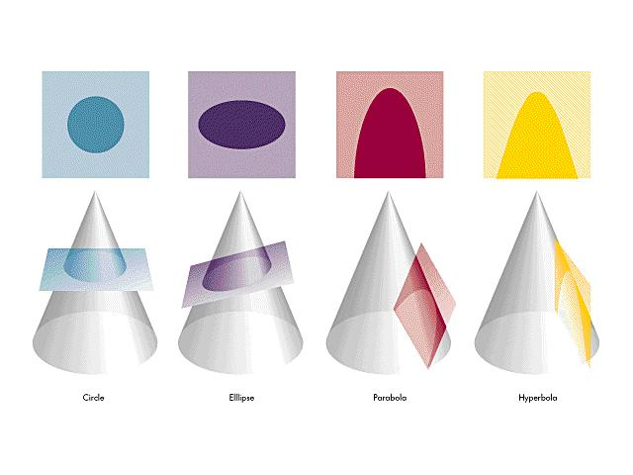

***Figure 6.*** *The basic conic sections as discovered by Apollonius.*

These curves were studied in detail, and the equations for them derived, so that in Cartesian coordinates, the equations for the ellipse and hyperbola are respectively



Or, in polar coordinates (r,θ) we have



where e =0 if the curve is a circle, 0 < e < 1 if it is an ellipse, e=1 if it is a parabola, and e > 1 if it is a hyperbola.

Like many areas of pure mathematics the conic sections were an answer looking for a problem. However that problem came with Kepler in the 1610s who was studying the motion of the planets. Kepler took data supplied by the astronomer Tycho Brahe and used it to investigate the latest theories of planetary motion. At that time there were three competing theories of the way that the planets moved in the heavens. The long standing Ptolemaic theory, in which the sun and the planets went around the Earth in a combination of circles and epicycles; the recent (and literally revolutionary) Copernican theory in which the planets (including the Earth) orbited the sun in circles, and theory of Brahe himself in which the planets orbited the sun, which in turn orbited the Earth. Whilst the Copernican theory had many advantages over the other theories in terms of its simplicity (and extraordinary elegance and power), Kepler found that it didn’t fit the data especially well, and from the point of view of experimental fit, the Brahe theory was possibly better. However, Kepler did not abandon Copernicus’ theory, instead he realised that it could be improved. The problem he realised was the insistence on circular orbits. The Greeks had chosen circles because they saw them (possibly correctly) as the most perfect of all curves, and thus the only possible orbits of the planets. What other possible orbit could there be? However Apollonius had worked out the answer 1500 years before. Kepler realised that if he replaced the circular orbits of the planets by elliptical ones, then everything worked perfectly. This was an astonishing fluke. The laws of motion could have had many solutions, but, to the great fortune of human civilisation, the solution which mattered was one which (in good Blue Peter fashion) someone had made earlier. Kepler went on to formulate his three laws of planetary motion, namely that the planets moved in elliptical orbits with the sun at the focus, they swept out equal areas in equal times as they went round, and that as the orbital distance cubed, so the orbital period squared.

***Figure 7:***  *A planet going round the Sun in an ellipse. The regions between the blue lines have equal areas, and are swept out in equal times.*

These laws allowed very precise calculations of the planetary orbits, which fitted the data perfectly, however no one knew at that stage why they were true. This remained the case until in the late 1600s, Sir Isaac Newton discovered the laws of motion and the law of gravity. The latter stating that the force acting on a planet from the sun was inversely proportional to the distance from the sun squared. Newton then used his newly created theory of calculus (together with a lot of geometry) to prove that Kepler’s laws followed directly from his theory of gravitation. Again this was a huge fluke, as most problems in applied mathematics don’t have an exact solution even if you can write down the equations describing them. A good example be the laws of fluid motion. However, again luckily for humanity, Newton’s equations did have a straightforward solution for the case of a single planet going around the sun, and this was the ellipse discovered by Kepler. (The law of equal areas corresponds to the conservation of angular momentum, and his third law is a direct consequence of the inverse square law). As we showed in Chapter One, so good were Newton’s theories that they led to the discovery of the planet of Neptune.

**4.2 The three body problem**

Such is our faith in Newton’s laws that they are now used for large scale calculations, including such delicate issues as the fate of the solar system and (indeed) of the whole of humanity itself. This involves calculating the orbit not of a single planet going around the sun, but of all of the objects in the solar system. There are a number of problems with doing this, all of which are the subject of significant on going research. Firstly, there is the sheer size of the problem, with not only the calculation of the planets but of all of the asteroids and other bodies in the solar system. Secondly, unlike the case of a single planet and the sun (the so called *two-body problem*) which (as we have seen) has an exact solution, as soon as we go to three or more bodies, there is simply no closed form solution. To give some idea of the complexity of the problem, the set of Newton’s equations for a problem with N planetary bodies of individual mass mi , and at position ri_is given by



Thirdly, as well as being essentially impossible to solve analytically, these equations are also hard to solve on a computer. The problem is that we usually want to solve these equations for a long time (to calculate the fate of the solar system we are talking of Billions of years. Over such a long period of time, errors made by the computer in solving the equations can accumulate over time, leading to very inaccurate solutions. However, recently great advances have been made in the development of numerical methods for which the errors made cancel each other out over long times. Such numerical methods, such as the recently studied *symplectic methods* are transforming our understanding of the long time evolution of the Solar system [5]. The final problem with solving Newton’s three (or indeed N-body) problem is that the solutions can be *chaotic* in exactly the manner described in Chapter 2*.* A typical such orbit is shown below and we can see that it is very different from an elliptical orbit.

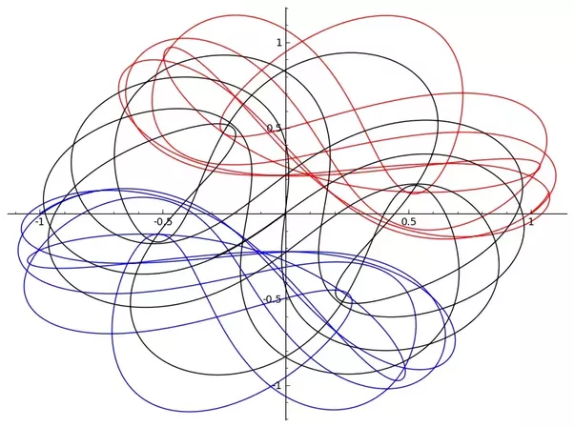

***Figure 8.*** *The chaotic trajectory of a solution of the three body problem.*

As we described in Chapter 2, the key fact about a chaotic or bit is that it is highly complex, and very hard to predict even with highly accurate numerical methods. The first person to recognise this was the great French mathematician Henri Poincare who we also met in Chapter 2. Poincare who was studying whether the solar system was stable. (The answer by the way is *maybe*.)

**4.3 Lambert’s problem and the elliptical orbit**

Whilst, as we have seen, the problem of finding the general orbits of the bodies of the solar system is hard, the problem of finding the motion of a satellite within this system is fortunately much easier. This is because a satellite is so small that it does not affect the motion of any of the bodies that it comes into contact with. Furthermore, a satellite will mostly be influenced by the gravity of the Sun, unless it comes close to a planet. We will look at this case presently, but will start with the more general case of the satellite moving under the gravity of the Sun. Whilst this is a modern problem for satellites, it was considered 250 years ago by Johann Heinrich Lambert (1728–1777). He was a Swiss mathematician who made a fundamental study into the orbits of bodies in the Solar System using Newton’s model of the Solar system, and his work is still in heavy use today in the direction of satellites. In [celestial mechanics](https://en.wikipedia.org/wiki/Celestial_mechanics) *Lambert's problem,* which he solved, is the problem of determining the orbit in space which takes a satellite from two different points in a given time. It has important applications in determining the preliminary orbit of the satellite, and allow it to be navigated from one point in the Solar system to another.

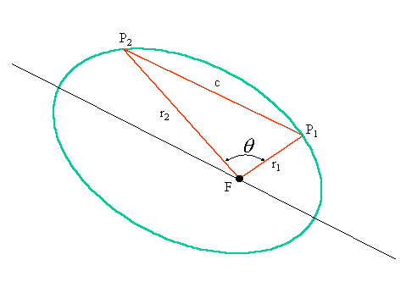

***Figure 9****. The elliptical orbit of a satellite around the Sun at the focus F of the ellipse.*

Lambert’s problem is illustrated by Figure 9 in which the question is to find the trajectory which a body in the solar system takes if it moves from the point P1 to the point P2 in a given time T. This problem is solved by assuming that the body moves in an elliptical orbit with the sun at its focus F (or in the case of a moon shot the Earth will be at the focus), which in turn tells us the angle it has to move in its orbit. The known geometry of the orbit allows the calculation of the precise parameters of the ellipse that it moves on to be made with relative ease. From these the complete trajectory of the satellite can be then calculated with high precision. More details are given in [6]. It is very nice that a model of the Solar system which assumes motion in the classical shape of a conic section discovered over 2o00 years ago, can have such important applications in modern technology.

**4.4 How some amazing women put a man on the moon**

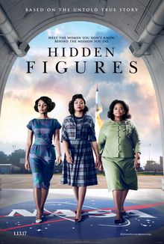

***Figure 10****. Poster advertising the 2016 Fox 2000 Motion Picture ‘Hidden Figues’ directed by Theodore Melfi*.

We now fast forward 200 years to the 1960’s in which a pressing need was to calculate the parameters of the orbit of the Apollo space missions to the moon. This had to be done without the benefits of powerful modern computers. Indeed the on board computer on the spacecraft themselves had (much) less computing power than that of a modern mobile phone. Instead the orbits were calculated in advance by mathematicians using versions of the Lambert problem described above. Remarkably (for the time) three of these were African American women including the mathematician Katherine Goble, the engineer Mary Jackson, and their supervisor Dorothy Vaughan. Their work is celebrated in the Hollywood film *Hidden Figures* and the book [7]*.* An example of such an orbit is illustrated below

**\*\*\* add more here\*\***

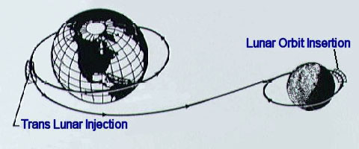

***Figure 11****. A trajectory of a Moon mission, starting from an orbit around the Earth, followed from a passage from the Earth to the Moon, and then an orbit around the Moon.*

So far so good, but in the case of Apollo 13 [8] in 1970 the calculations had to be rapidly revised when the space craft was severely damaged on the way to the Moon by the explosion of one of its Liquid Oxygen tanks followed by the shutting down of the Command Module. Following this the astronauts had to enter the Lunar Module which had to then take them back to Earth along an unplanned orbit. It is a huge tribute to the orbit calculators at NASA in Houston that the astronauts were able to return safely to Earth. My teacher at primary school involved us all thoroughly in the unfolding drama of this mission and it made a huge impression on me at the time.

**4.5 Sling shots and hyperbolic orbits**

Whilst the orbits of bodies around the sun are ellipses, it is another type of orbit, the hyperbolic orbit, which plays a vital role in long distance travel in the Solar system. Suppose that you are on the surface of a body, such as the Earth, and throw a projectile into space with a velocity v. Our usual experience is that the projectile will slow down due to the effects of gravity, and will eventually reverse its direction before falling back to the Earth. However, if you throw the particle with a high enough velocity v then it will ‘escape the gravity of the Earth’ and will continue to move to infinity (or at least as far as the edge of the universe). For the Earth this escape velocity Ve is given by



This value is 41% higher than the velocity needed to insert a satellite into a near Earth orbit. (On the event horizon of a black hole this velocity is the speed of light of 3 million km/s.). If the velocity v is higher then the escape Ve then the body will move on a hyperbolic orbit around the Earth. Similarly if a body moves faster than the escape velocity of the Sun then it will move on a hyperbolic orbit around the Sun, as illustrated below.

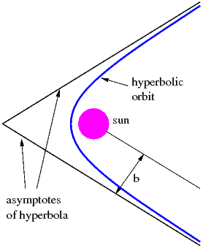



***Figure 12.*** *A hyperbolic orbit around the Sun, showing the limiting asymptotes and the deflection angle θ∞*

Roughly speaking a hyperbolic orbit comprises an almost straight section which approaches one of the asymptotes of the hyperbola, along which the body has a near constant velocity of approach relative to the Sun which is v∞ and is given by the formula



This is called the *hyperbolic excess velocity*. The body then speeds up as it approached the Sun (or any other large object) reaching a maximum velocity of v close to the Sun. It then swings around the Sun and leaves on another straight path, approaching the other asymptote of the hyperbola, reaching a departing velocity of v∞**.** By doing so it changes its direction of motion.

This phenomenon is exploited in the *sling shot effect* which is used to take satellites to the distant planets by swinging them around other large planets on the way. The sling shot effect is used to change their direction, and the gravitational pull of the large planet is used to speed them along their way. Consider for example a satellite going to Pluto via the large planet Jupiter. If guided correctly it will go on a hyperbolic orbit around Jupiter approaching on one asymptote of the hyperbola. As it approaches Jupiter at a relative approach velocity of v∞ it will accelerate towards it because of its gravity attraction, swing around it on a hyperbolic orbit and then move away at a departing velocity of v∞ (again) relative to Jupiter and along the other asymptote. This the angle of its path has changed. However, whilst all of this is happening Jupiter is moving around the Sun at an orbital velocity of about 13 km s-1. The effect of being dragged along by Jupiter not only changes the angle of its path but can also increase its speed significantly without any fuel being burnt. Essentially the gravitational attraction of Jupiter gives the satellite some additional energy to continue its orbit. As no energy can be gained or lost in the encounter the same amount of energy is lost by Jupiter, but as it is so massive its orbit is scarcely affected.

This can all be made very precise mathematically by using the known geometry of the hyperbolic orbit. The key parameters of a sling shot around a massive planet of mass M are the approach velocity v∞ of the satellite relative to the planet and the (so called) *impact parameter* b (illustrated in Figure 12) which it the closest approach that the satellite would make to the planet if it were not affected by the gravity of the large planet. It then follows from the Newtonian model of the Solar system that the satellite’s orbit is deflected by an angle 2π-2θ∞ between the lines of approach and departure where



Here as before we have



where G is the Gravitational constant and M is the mass of the large planet. The larger that M is, the more the satellite will be deflected by the sling shot effect.

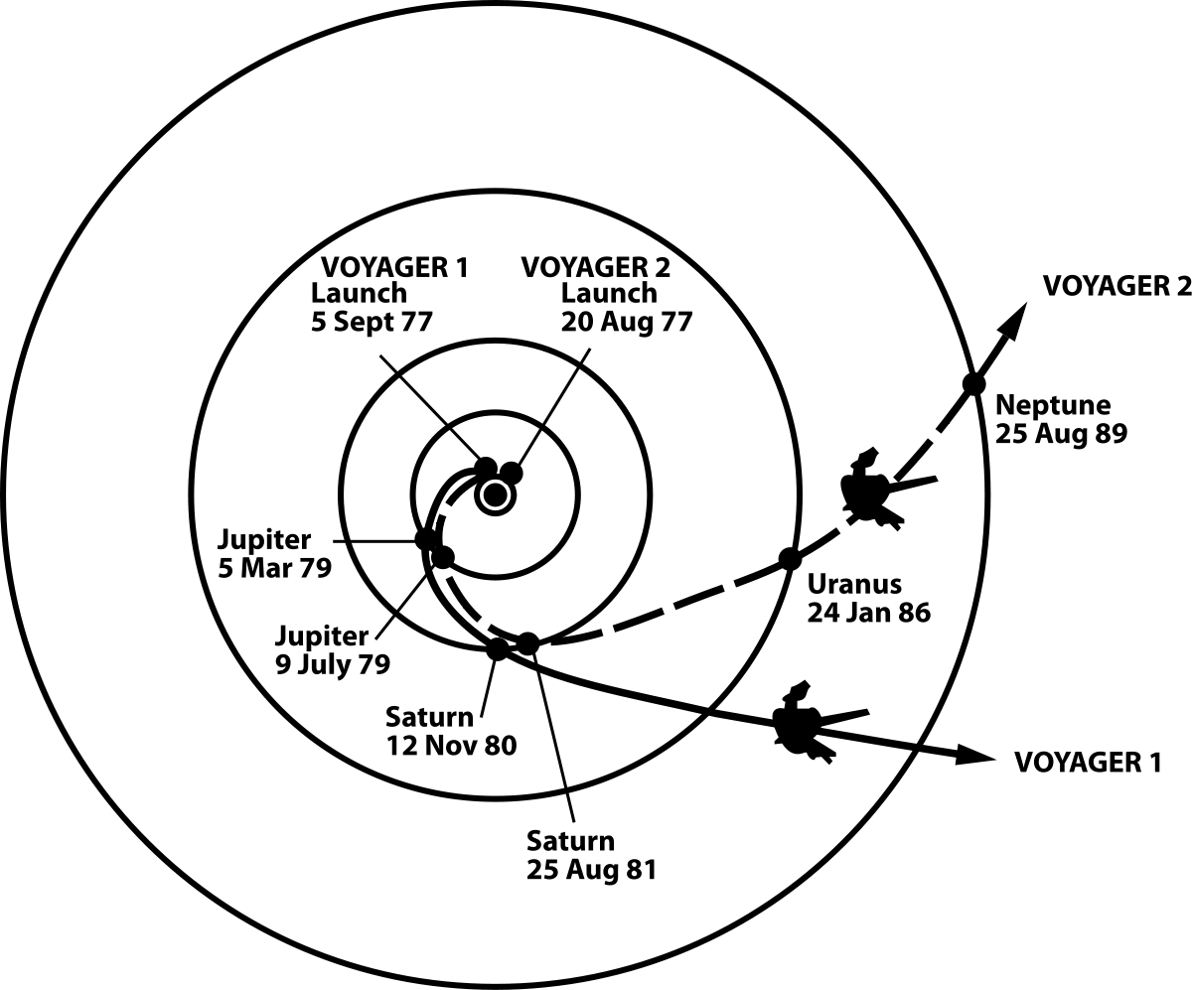In a deep space mission then the designers of the trajectory of the satellite may make use of a number of gravity assisted sling shots to propel to satellite to the distant planets. Below you can see the orbits of the Voyager probes (launched in 1977) as they passed by Jupiter and Saturn on their way to Uranus, Neptune and the edges of the Solar system and beyond (and according to Star Trek the Motion Picture, back again).

***Figure 13.*** *The trajectory of the Voyager satellites, which used the sling shot effect around Jupiter and Saturn to reach Uranus and Neptune.*

Similarly, the Galileo probe to Jupiter was launched from the Earth, had a gravity assisted sling shot from Venus, returned back to Earth twice to have further gravity assists all of which raised its orbital energy. Finally it made it to Jupiter after six years. All it needed to do this was a small excess velocity of 3 km/s above the escape velocity needed to leave the Earth’s orbit. This compares with the much shorter, but much more expensive (in fuel), method of launching the satellite directly at Jupiter. A film of the projected orbit of the European Space Agency JUICE satellite to Jupiter is given in [9].

1. **To deep space and back again**

As we have seen above, Newton’s laws of motion do a remarkably good job in predicting the motions of satellites and the planets. If we think of the modelling process, and **Step 7** then any model which used Newton’s laws was felt to be complete by any astronomer up to the start of the 20th century (and indeed as we have seen above, they still work incredibly well in the Solar system). The physicists of the 19th Century were confident that the laws of physics had all been determined, only a few constants needed to be found to complete the models that they used to describe the universe. They were wrong! In 1905, possibly one of the most remarkable years in the history of science, Einstein published three astonishing papers which transformed science and the way that we look at the world. These were on Brownian motion and Kinetic Theory, the Photo Electric effect in Quantum Theory and (possibly most famously) his paper on the *Special Theory of Relativity (SR)*. In 1915 Einstein followed this with the publication of his wholly remarkable paper on the *General Theory of Relativity (GR).* This latter paper developed a model for the Universe which departed from Newtonian mechanics and gave a (new) theory of gravity. This explained gravity it in terms of the distortion of space-time by massive bodies. (Note that for speeds rather lower than the speed of light, and for bodies of the mass of the Earth and the Sun, then the equations of General Relativity very closely approximate those of Newtonian mechanics. This is why the model of the Universe based on Newtonian Mechanics is still very useful for most calculations.) The General Theory of Relativity is summarised by the *Einstein Field Equations* which represent how the *curvature* G of space time is changed by the *mass tensor* T and have the form



Although these may look simple, they are a short hand for a large number of simultaneous partial differential equations, and are very hard to solve. Despite this there were a number of extraordinary predictions of the General Theory of Relativity. Two of these were that light should be deflected in a certain way by a massive body (such as the Sun) and that the orbit of the planet Mercury should slightly differ from the true ellipse predicted by Newtonian mechanics. Both of these predictions were validated by experiment not long after the publication of the theory, giving confidence in its predictive powers which went beyond, and differed from, the predictions of Newtonian mechanics. Two more predictions were the existence of Black Holes (massive stars for which the escape velocity Ve is higher than the speed of light) and of the expansion of the universe. Although it took longer to find, there is now extremely strong evidence to support both predictions. Indeed massive Black Holes are now known to be at the centre of galaxies such as our own. One year after the publication of his theory, Einstein made another mathematical prediction, that of Gravitational Waves. These are ripples in space time which travel at the speed of light. This prediction has taken much longer to verify. This is because, despite being created by huge astronomical events, such as the collision of black holes or of neutron stars, by the time that they reach us, the ripples through space-time are less than the width of an atom. However, in a piece of work that has recently (and very correctly) been awarded the 2107 Nobel Prize for physics (to Rainer Weiss, Barry Barish and Kip Thorne), Gravitational Waves have been detected. This discovery was made on the 14th September, 2015, by the bar detectors of LIGO (Laser Interferometry Gravity-Wave Observatory) detector in Louisiana which measured the Gravitational Waves given off by the collision of two massive black holes a billion light years away. Since 2015 there have been several recordings of gravitational waves, with three coming from the collision of black holes, and very recently one from the collision of two neutron stars. A whole new era of astronomy using Gravitational Waves has just started. This is a splendid demonstration that a mathematical prediction can come true and have profound consequences.

We now come back to Earth, or at least close to Earth, with a wonderful practical application of the General Theory of Relativity to satellite technology. One of the most important uses of modern satellites is in GPS navigation. Most of us will have GPS location devices in our car and/or our smart phones. It is essential for the accuracy of GPS systems for the satellites to tell the time to very high precision, as the navigational method relies on measuring the time difference between the signals received on the Earth from a number of GPS satellites. If Newtonian mechanics were completely accurate then a satellite would tell the same time as on the Earth. However, owing to the effects predicted by both the special and general theories of relativity this is not the case. Firstly the satellites are travelling at a high speed which causes their clocks to run slow (a prediction of special relativity) by about 7 microseconds per day . Secondly the Earths gravity is weaker at the satellite than on the surface of the Earth. According to the General Theory of relativity this also causes the clocks to run faster, by about 45 microseconds per day. The total correction due to relativistic effects is then 38 microseconds per day. This leads to an improvement in GPS accuracy of the order of hundreds of metres. This can make all the difference there is the to use of GPS in applications such as navigation, surveying, or landing an aircraft.

1. **A bit of Origami**

We finish this Chapter by looking at a link between space, maths and the art of Origami. When a satellite is sent up into space it has to fit inside a small rocket. However, when it gets into space then it has to deploy large solar panels in order to gain energy from the Sun. The designers of the satellites thus have the problem of how to fold a solar panel into a small space. Fortunately mathematicians already have the answer to this problem in the shape of the mathematical algorithms now used to design Origami patterns. One of the leading figures behind this is Robert Lang, who is simultaneously a mathematician, an Origami master and a rocket scientist. Who could ask for more. You can find out more about Origami and space in [10].

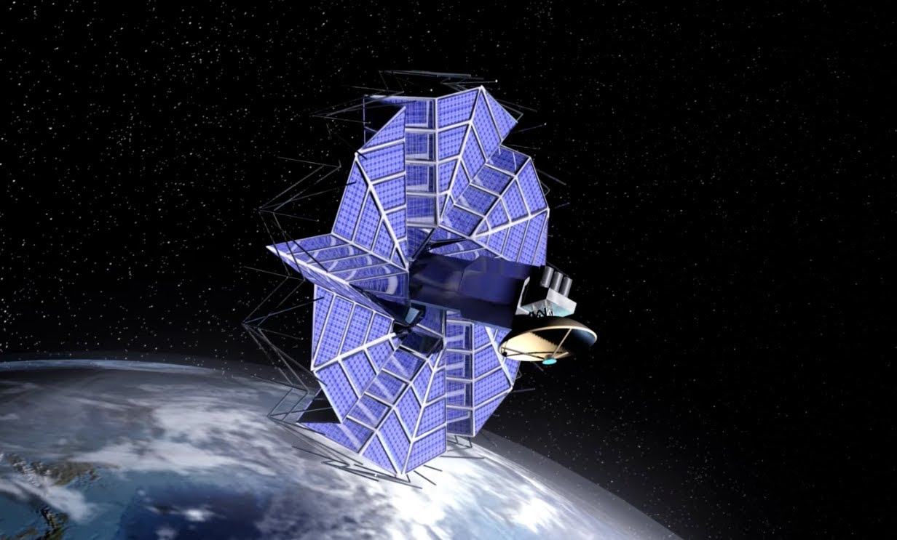

***Figure 14.*** *Unveiling the photo cells of a satellite using Origami*

**7. References**

[1] *Maths Today* which is the popular journal of the Institute of Mathematics and its Applications has a special edition on *Maths in Space* (October, 2017) which contains lots of information relevant to this Chapter.

[2] C.F. Gauss, *Disquisitiones Arithmeticae*, (1801)

[3] C. Budd and C. Sangwin, *Analemmatic sundials and how they work*, https://plus.maths.org/content/analemmatic-sundials-how-build-one-and-why-they-wor

[4] A. C. Clarke, *Extra-Terrestrial Relays*, *Wireless World*, Vol. 51, No. 10, pp. 305–308, 1945

[5] E. Hairer, C. Lubich and G. Wanner, *Geometric numerical integration*, (2002), Springer

[6] Orbital mechanics http://www.braeunig.us/space/orbmech.htm

[7] The story of the amazing women who worked for the Apollo is described in the book *Hidden Figures* by Margot Lee Shetterly (2016) published by William Morrow and Company.

[8] J. Kluger and J. Lovell, *Apollo 13,* (1995)

[9] An animation for the orbit of the ESA Juice probe to Jupiter is given in <https://www.youtube.com/watch?v=uMyaIphWp1A>

[10] Origami in space https://www.youtube.com/watch?v=3E12uju1vgQ